Matt Cifarelli and Skyler Cobb

Project 2 Write Up

12/10/21

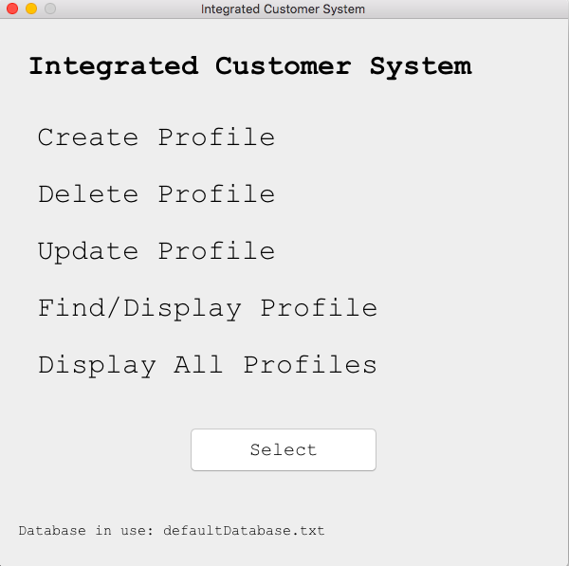

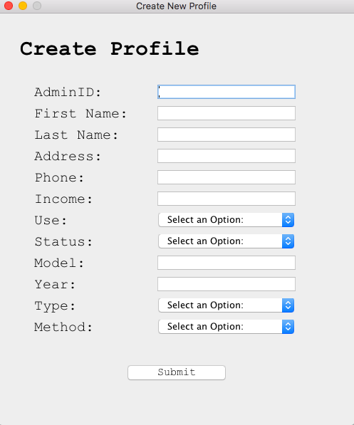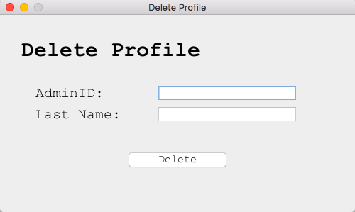

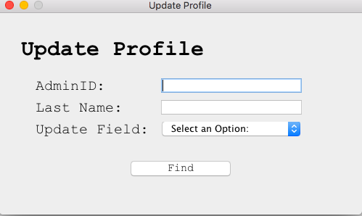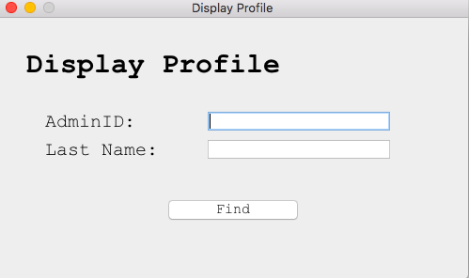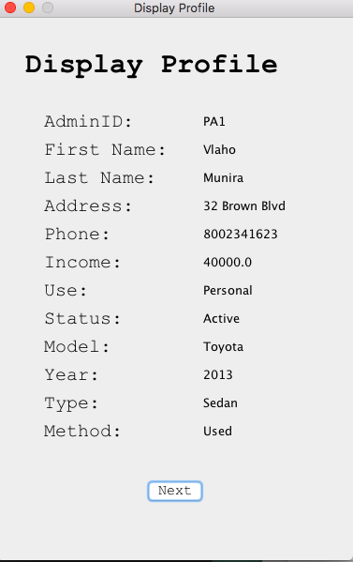

*For Display Profile, clicking next goes to the next profile until all profiles are looked at

**How work was divided:**

Mainly, Skyler took care of the general code and formatting for all of the GUI’s. This was because He had experience in this and was able to do it much quicker and easier than Matt would have. Also, Matt was involved in that aspect as well, however mainly for cleaning up the code, fixing minor errors and bugs, and error handling within the GUI. We thought this breakup of the work would be best considering each of our strengths and the schedules we had, basically based on when we could work on it for longer periods of time. This allowed Skyler to use his knowledge in GUI building and experience while Matt was able to debug things and look at the program as a whole working unit, with Skyler doing the designing of the GUI. This we found worked best for both of us given time constraints and general knowledge and strengths with the project.

**Time spent:**

We spent a total of around 12 hours on implementation in total and testing/debugging took about 4 hours

**Difficulties:**

We encountered a handful of difficulties with this project. For starters, Matt’s knowledge of the GUI system, and how it could be implemented was severely lacking, so it took a while for him to be able to understand the process and the code required for a project of this caliber. Next, the implementation of the GUI, and how it would look was difficult to set up, as there are an infinite number of designs to do and we wanted one that looked professional and realistic, as well as fully functional and not too much. Finally, it was difficult to deal with some problems within our code such as our Profile Delete GUI not working properly, and us having to basically redo our Find Profile function. In the end we made the necessary changes and it was worth it, but it was difficult to already have somewhat working code but to have to get rid of it all in order to try and make it work regardless of some random factors.

**Extra Credit/ Error Handling:**

For the extra credit portion, we did a lot of work in regards to how the program would act if for example, not all fields were filled in, or there was an invalid input. For all of our different GUI screens and possible actions, there is some sort of error handling in regards to an incorrect entry, where there will be a pop up that says the input is wrong. Also, specifically for options with a drop box selection, if one is not chosen a different error will pop up, stating the user must select a valid option. Finally, for all the different potential actions, for example if. A profile is not found, or if a profile to be deleted is not part of the database, or if you type in a string not a float for the ‘income’ section when making a new profile, there is unique messages that apply based on the situation, giving the user feedback in order to properly use the system.